Home page: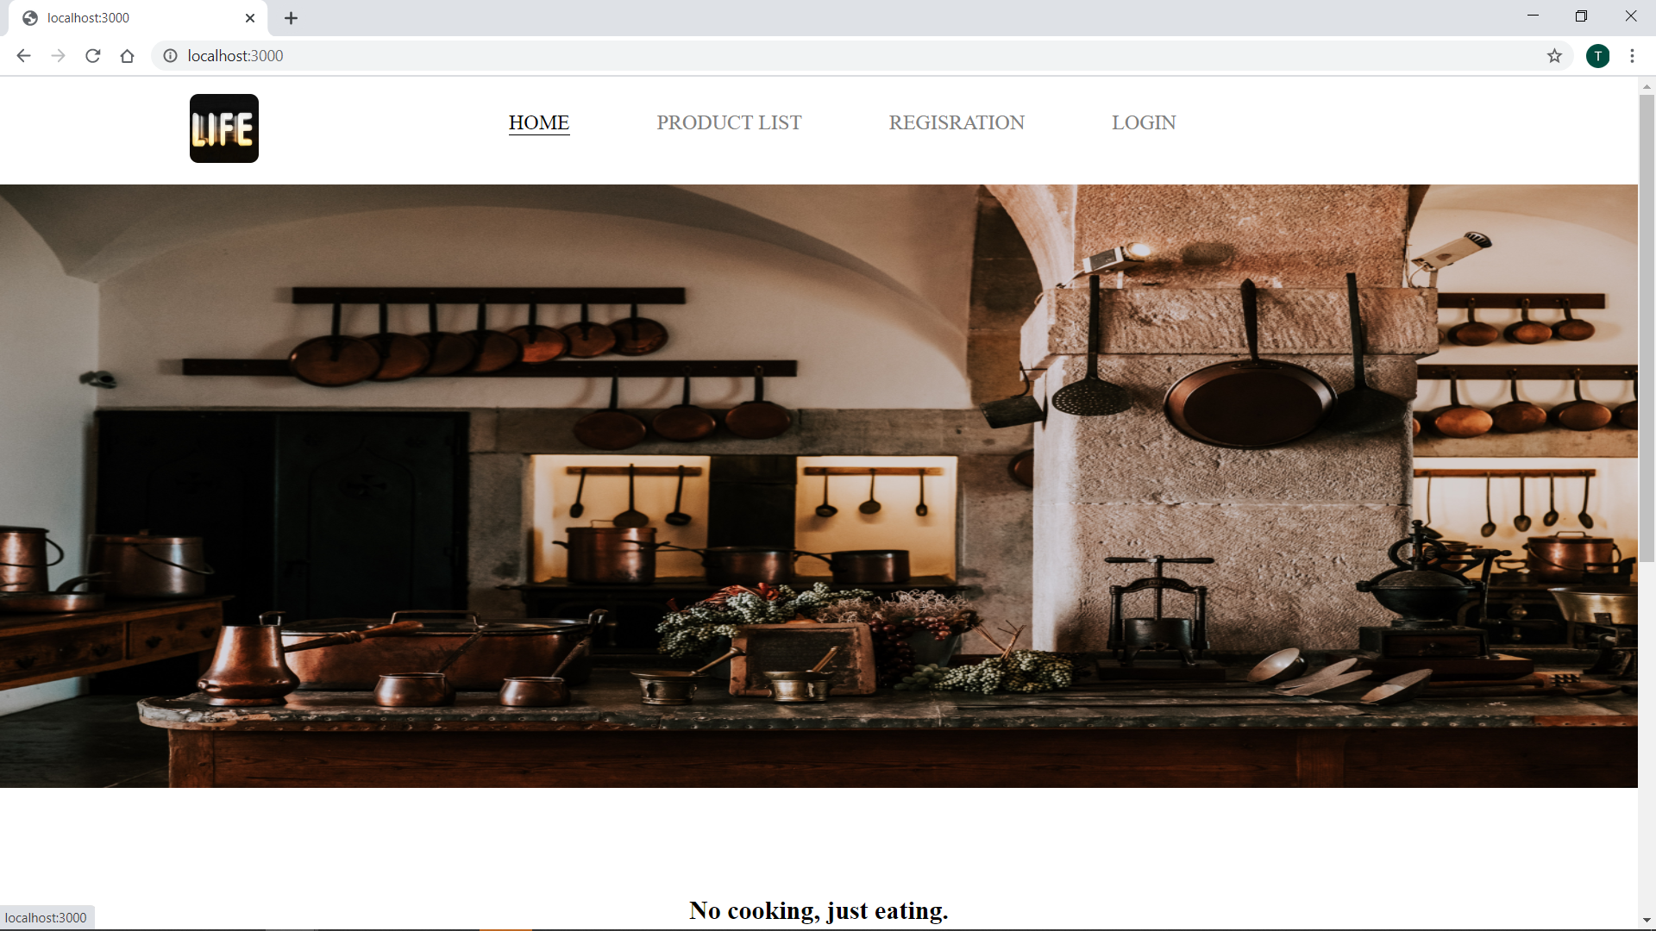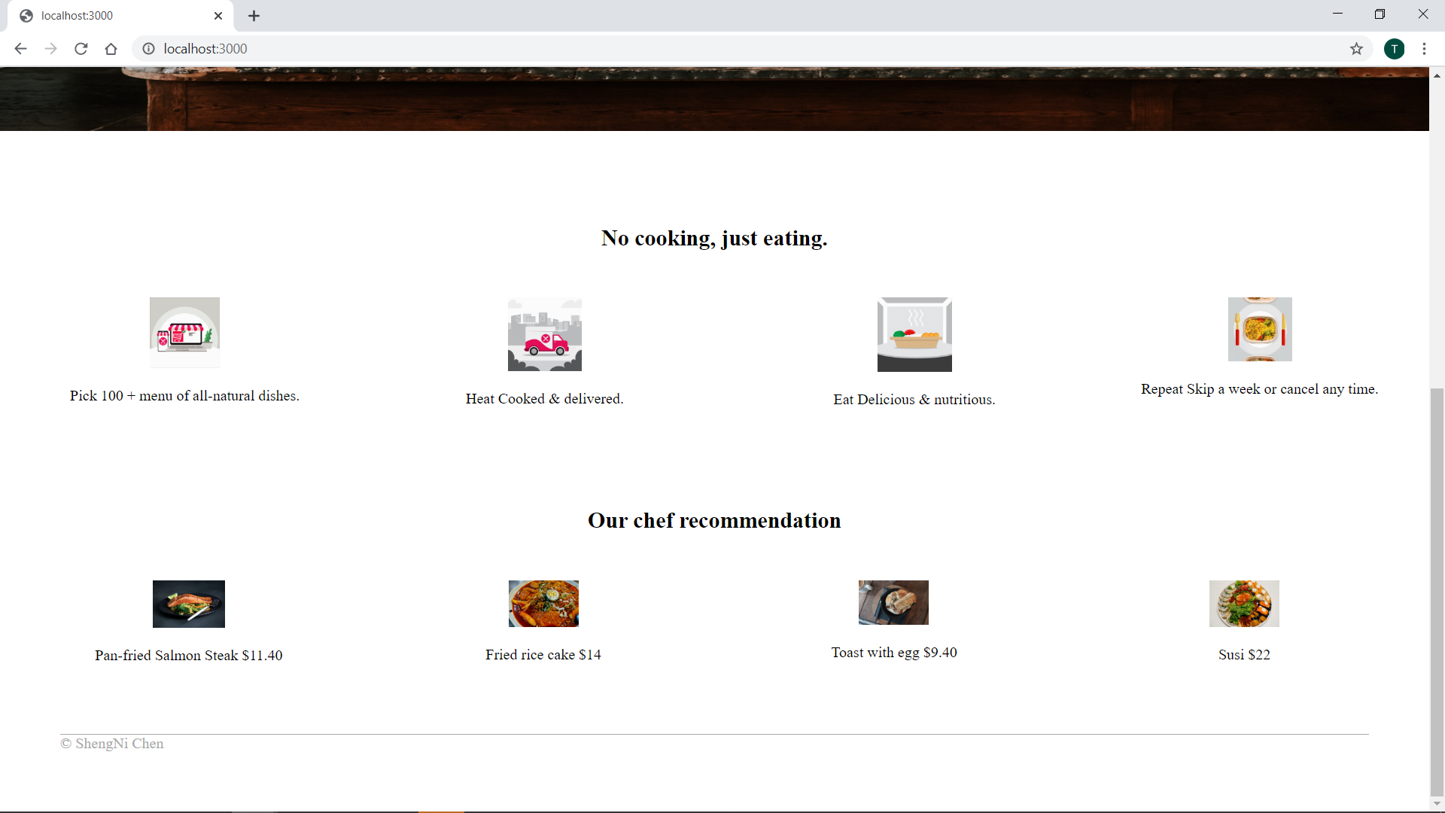

The logo I had add a hyper link so it is also can navigat back to home page. 4 hyper link become more fancy. I use js to stroe the data and use express to loop out the data in the js files.

Package page

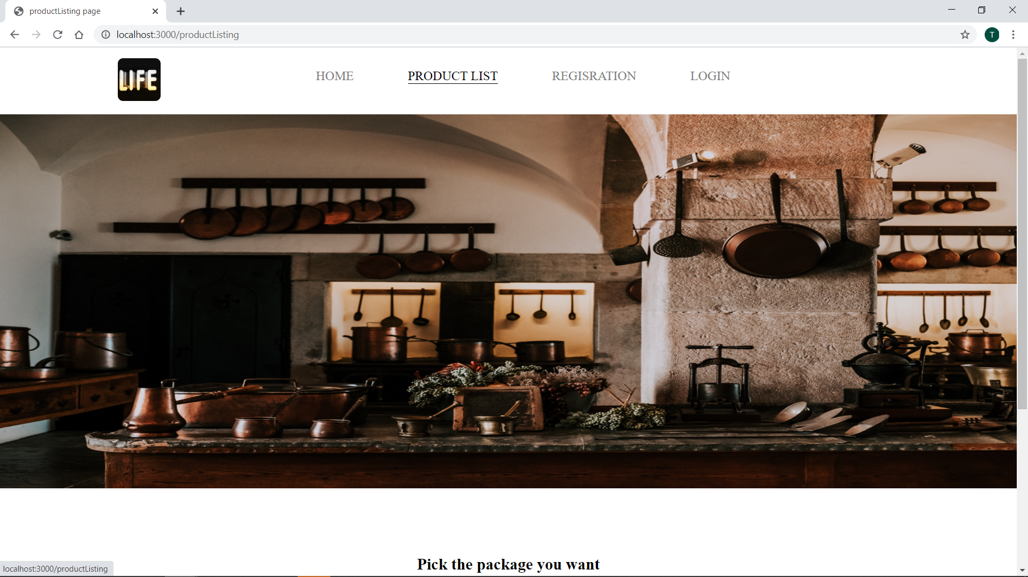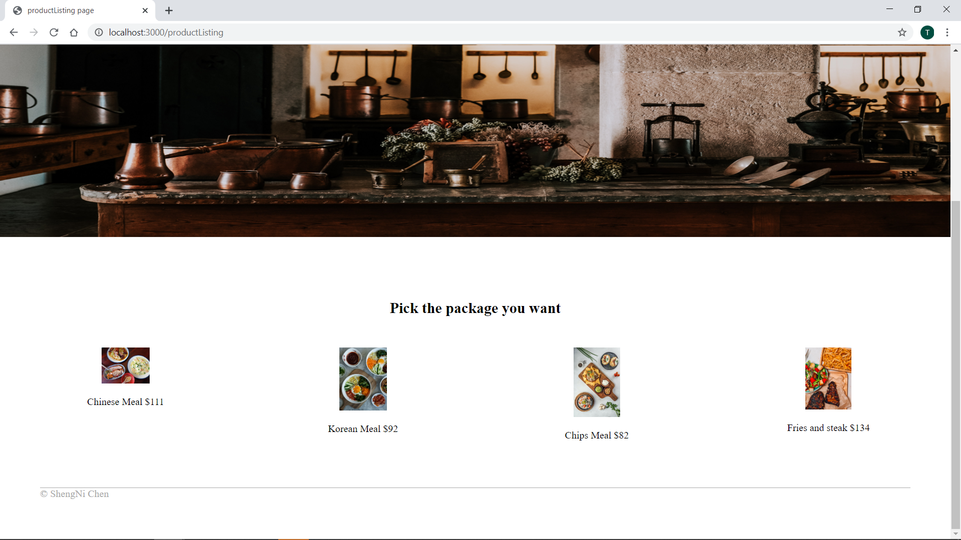

Restration page

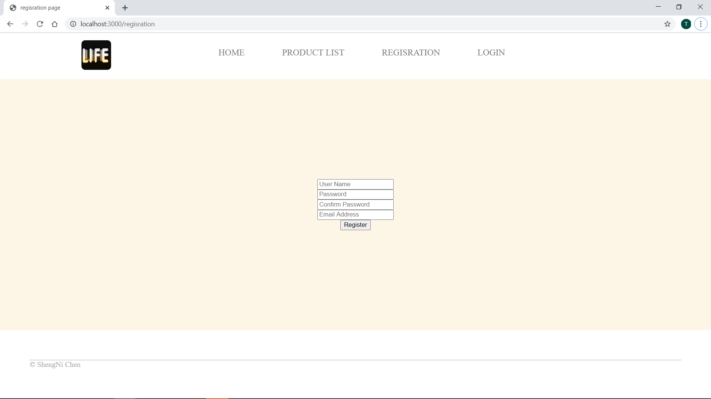

I am not sure how to have a data file and let the html page to know is the account exit or not.

Login page

